Elementary School Supply List

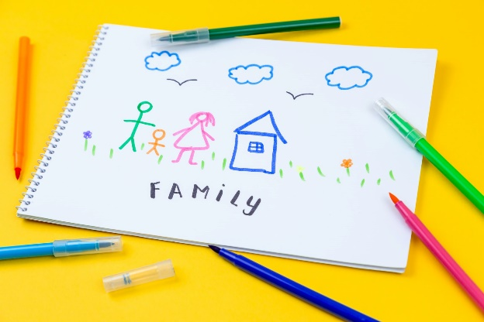
- 3 boxes of crayons (24 count)
- 1 pair of scissors
- 6 glue sticks
- 24 count pencils (preferably pre-sharpened)
- 1 box pencil-top erasers
- 2 dry erase markers
- 2 marble composition notebooks (not spiral and different colors)
- 2 packages of wide ruled notebook paper
- 1 box of colored pencils (8 pack)
- 1 box of markers (8 pack)
- 1 box of highlighters (multiple colors)
- 1 sticky note pad, 3-inch square (such as Post-its)
- 1 two-pocket folder labeled with name
- 1 bottle of hand sanitizer
- Clorox (or similar) wipes
- Box of tissues
- 1 pair of corded headphones
- Boys - a box of quart zipper bags
- Girls - a box of gallon zipper bags

