Improving Your Ally Score on Documents

Checklist for Improving your Ally score
While creating website content it is crucial to consider accessibility. There are a few basic steps that should be followed in order to assure your Ally score is increased:

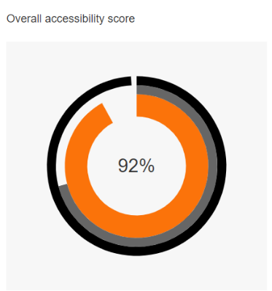
Add built-in Headings to document and do not skip numbers (e.g. jumping from Heading 1 to Heading 3)
Use built-in List options (e.g. bullets or numbers)
Links should be descriptive text
Add Alt Text for all images
Define Table Headers and simplify Tables as much as possible
Use the built-in accessibility checker

Helpful Information:

https://help.blackboard.com/Web_Community_Manager/Administrator/Accessibility
https://support.office.com/en-us/article/accessibility-support-for-word-c014d8b8-4ef3-4a7a-935d-295663f3343c

Sample Table:
 | Start Time | End Time
Monday | 8:05 AM | 3:05 PM
Tuesday | 8:05 AM | 3:05 PM
Wednesday | 10:05 AM | 3:05 PM

This is page 2

This is page 3

